SIMATS ENGINEERING
Department of Computer Science and Engineering
CSA15 Cloud Computing and Big Data Analytics
CO3 AT2 – Capstone Cloud Access and Service Integration Case Study
Case-study reasoning connecting CO3 AT1 concepts to the capstone product design

Assessment Metadata
Field | Details
Course Code | CSA15
Course Title | Cloud Computing and Big Data Analytics
Assessment | CO3 AT2 - Capstone Cloud Access and Service Integration Case Study
Submission Type | Individual digital case-study document
Faculty | Dr. C. Rajesh Babu
Employee ID | SSETSCS-415
Mode | Case study / capstone design reasoning
Submission | GitHub repository link through Google Classroom

How This Template Works
Read each case, connect it to the technical ideas learned in CO3 AT1, and then extend the design to the capstone product. The answer shows cloud access, APIs, storage, serverless/event flow and edge/fog/cloud reasoning. No passwords, private keys, API tokens or sensitive personal data are included anywhere in this document.

Student and Capstone Details
Field | Student Entry
Student Name | [Dheepak K]
Register Number | [19411108]
Class / Slot | Slot C
Capstone Title | NewsTrust: Cloud Misinformation Monitor Using NLP Credibility Scoring
CO3 AT1 Evidence Link | [Link to CO3 AT1 submission / evidence folder]
GitHub Repository Link | [GitHub repository link to be added]
Submission Date | [Submission Date]

Case 1: Cloud-Native Backend and Web API Architecture
Scenario | A food delivery company wants to deploy a cloud-native backend with web APIs, browser/mobile clients and shared cloud storage for receipts and delivery images. Design the architecture and explain the role of each component.

A. Case Architecture Diagram
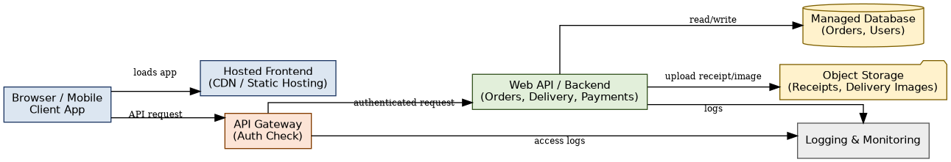
Figure 1: Cloud-native backend architecture for the food delivery scenario.

B. Component Role Explanation
• Browser/Mobile Client App: the customer- and rider-facing surface; calls the hosted frontend to load the UI and calls the API Gateway directly for data operations (place order, track delivery, upload receipt).
• Hosted Frontend (CDN/static hosting): serves the compiled web/mobile app assets from edge locations for fast load times, independent of backend scaling.
• API Gateway (Auth Check): the single entry point for every API call; validates the user's token/session and role before forwarding the request, and centralizes rate limiting and access logging.
• Web API/Backend: contains the business logic for orders, delivery assignment and payments; the only component allowed to talk directly to the database and storage.
• Managed Database: stores structured, relational data — orders, users, delivery status — with the provider handling backups, replication and failover.
• Object Storage: holds unstructured files (receipt images, delivery-proof photos) referenced by a URL/key from the database rather than stored as binary blobs in the database itself.
• Logging & Monitoring: collects access logs from the gateway and application logs from the backend so failures and unusual traffic can be traced after the fact.

C. Capstone Extension: user-to-cloud workflow for NewsTrust
The same layered pattern applies directly to NewsTrust. A registered reader or analyst opens the web app, which is served from a hosted frontend (CDN/static hosting) exactly like the food-delivery client. Every data action — searching an article, viewing a credibility score, submitting a misinformation report — goes through a REST API Gateway that checks the user's role (Reader, Analyst, Admin) before the request reaches the Backend API. The Backend API is the only component with direct access to the managed database (articles, sources, scores, users) and to object storage (stored article snapshots and exported fact-check PDFs). Logging and monitoring sit alongside the gateway and backend so that scraping failures, scoring errors or suspicious report spam can be traced. The one addition NewsTrust needs beyond the food-delivery pattern is an asynchronous path for the NLP scoring pipeline, covered in Case 2.

Case 2: Storage and Serverless Upload Workflow
Scenario | A media startup must decide between SAN-backed storage, object storage and serverless processing for upload workflows. Recommend a deployment model and justify it.

Data / Event | Best Storage | Serverless Action | Reason
Raw uploaded media file | Object storage (raw bucket) | Storage-trigger event on upload | Object storage is durable, cheap at scale, and natively supports event triggers
Active in-progress edit session | SAN-backed storage (workspace volume) | None (direct attached read/write) | SAN offers low-latency, high-IOPS block access needed while a file is being actively edited
Transcoding / thumbnailing / virus scan | N/A (compute, not storage) | Serverless function invoked by the upload event | Short-lived, bursty, event-driven work is a natural fit for pay-per-invocation compute
Processed/published media | Object storage + CDN | Notification function on completion | Read-heavy delivery benefits from CDN caching in front of the processed bucket

A. Storage and Serverless Recommendation
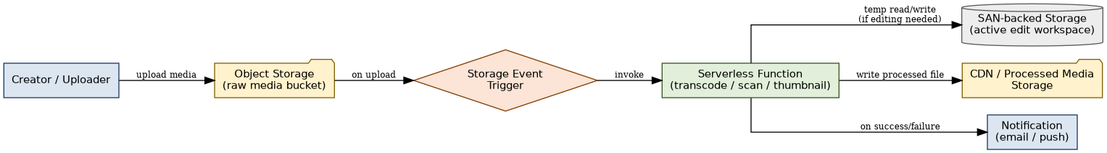
Figure 2: Storage and serverless upload/processing workflow for the media startup scenario.
Recommendation: use object storage as the landing zone for every raw upload, trigger a serverless function on the upload event to transcode/scan/thumbnail the file, and write the result to a processed-media bucket served through a CDN. Reserve SAN-backed storage only for the narrow case of an active, low-latency edit workspace — it is too expensive and too tightly coupled to a single server to use as the general-purpose store.

B. Failure Handling and Cost/Performance Explanation
• Failure handling: if the serverless function fails (corrupt file, unsupported format), the event is retried a limited number of times and then routed to a dead-letter queue so the failure is visible instead of silently dropped; the raw file in object storage is never deleted until processing succeeds.
• Cost: object storage and serverless are both pay-per-use, so idle time costs nothing — important for a startup with unpredictable upload volume. SAN storage is provisioned and billed continuously regardless of use, so it is kept small and reserved only for active editing.
• Performance: object storage/serverless trades a few seconds of processing latency for elastic scale, which is acceptable for background processing; SAN is used only where sub-millisecond, continuous access is actually required.

C. Capstone Extension: one upload/event workflow for NewsTrust
NewsTrust's ingestion pipeline follows the same object-storage-plus-serverless pattern. When the scraper (or a manual submission) lands a new article, the raw article snapshot (HTML/screenshot) is written to an object storage bucket. That write raises a storage event which pushes a message onto the ingestion Message Queue. A serverless NLP scoring function is triggered from the queue, runs the transformer-based credibility model, writes the resulting score, bias flags and source-reliability update to the managed database, and stores the permanent snapshot/report in the processed-articles bucket. If scoring fails (unreachable source, corrupt HTML), the event is retried and then moved to a dead-letter queue so an analyst can review it manually, and the raw snapshot is retained in object storage regardless of scoring success.

Case 3: Edge, Fog and Cloud Placement
Scenario | A smart-city platform needs low-latency decision-making near sensors while still using the cloud for analytics. Decide what runs at edge, fog and cloud.

Task | Layer | Latency Need | Data Volume | Reason
Detect vehicle at a traffic signal and trigger the light | Edge | Milliseconds | Low (single sensor reading) | Safety-critical, cannot wait on a network round trip
Aggregate readings from all signals in one district | Fog | Seconds | Medium (many sensors, short window) | Local aggregation reduces data sent onward and enables district-level coordination
City-wide traffic/air-quality trend analytics and ML model training | Cloud | Minutes to hours | High (city-wide, long history) | Needs large-scale storage and compute not available near the sensors
Public dashboard for residents | Cloud | Seconds | Medium (pre-aggregated) | Best served from centrally hosted, cacheable infrastructure

A. Edge/Fog/Cloud Architecture Explanation
Figure 3: Edge, fog and cloud placement for the smart-city scenario.
Sensors feed an edge device that makes an immediate, local decision (e.g., extend a green light) without waiting on the network. The edge device forwards filtered/summarized events to a fog node that aggregates readings from a wider local area over a short window. The fog node forwards batched, aggregated data on to the cloud, which handles long-term storage, cross-district analytics, ML model training and the resident-facing dashboard. Each layer only sends upward what the next layer actually needs, keeping bandwidth and latency proportional to the decision being made.

B. Capstone Extension or Direct Cloud Access Justification
NewsTrust has no sensor/IoT tier and no sub-second, safety-critical decision to make locally, so an edge/fog layer is not applicable to it. Every client — reader, analyst or admin — connects directly to the cloud over the internet through the REST API Gateway shown in Case 1. This direct-cloud-access model fits because: (1) NLP credibility scoring is not latency-critical in the millisecond sense — a few seconds of processing time before a score appears is acceptable; (2) the workload benefits from centralized, elastic compute (the transformer model and its dependencies are heavy to run anywhere except a properly sized cloud instance, as sized in CO2 AT1); and (3) there is no local hardware NewsTrust controls the way a smart-city platform controls roadside sensors. Direct cloud access, rather than an edge/fog tier, is therefore the correct and simpler placement decision for this capstone.

Final Capstone Cloud Access Architecture
Checklist covered by the diagram below:
• Browser/Mobile Client shown
• Hosted frontend / app access path shown
• REST API endpoint and authentication check shown
• Backend/serverless logic shown
• Database, object/blob storage, logs and monitoring shown
• Arrows labeled: request, response, upload, event, notification or monitoring signal

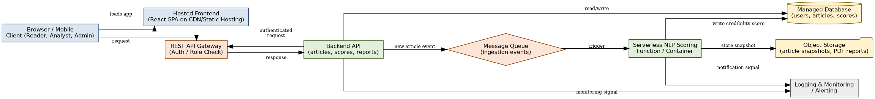
Figure 4: Final NewsTrust cloud access and service integration architecture.

Final Diagram and Explanation
A Browser/Mobile Client (used by readers, analysts and admins) loads the app from the Hosted Frontend and sends every data request to the REST API Gateway, which performs the authentication/role check before forwarding an authenticated request to the Backend API; the Backend API sends a response back through the gateway to the client. The Backend API reads and writes structured data (users, articles, scores, reports) directly to the Managed Database. When a new article is ingested, the Backend API publishes a new article event onto the Message Queue, which triggers the Serverless NLP Scoring Function; that function stores the raw snapshot/report as an upload to Object Storage, writes the resulting credibility score back to the Managed Database, and raises a notification signal on completion or failure. Both the API Gateway/Backend API and the serverless function continuously emit monitoring signals to Logging & Monitoring, giving a single place to trace a request, an upload, an asynchronous event and a notification end to end.

Submission Checklist
☐ Template completed in DOCX format.
☐ Diagrams pasted clearly in the document.
☐ GitHub repository contains DOCX/PDF, diagrams and README.
☐ Google Classroom submission contains GitHub link.
☐ Sensitive credentials are not visible anywhere.

Student Assurance

Declaration
I confirm that this case-study answer, cloud access design, diagrams and capstone extensions were prepared individually by me for the stated capstone title.

Student Signature : K DHEEPAK Date: 03/09/2026

